Telusko: Advance Java 03

143 Need of Spring, Introduction to IOC container, Types of Dependancy Injection, Setter injection in core java style

Java Learning is all about 3 things
a. Java Language(Core java course)
b. Java Technology(JDBC,Servlet,JSP,JSTL,EJB's,JMS,....)
EJB-> Enterprise Java Bean
JMS-> Java messaging Service
c. Framework(Hibernate,Spring,SpringBoot,MicroServices,RestApi's,....)
Framework is not a new technology, rather it is an abstraction provided on top of
technology.
Thirdparty team would give apis in the form of jars which would generate boiler
plate code based on the inputs we give to the internal containers of the framework.
eg: hibernate -----> based on configuration details supplied, it will create
JDBC environment.
Spring -----> based on configuration details supplied, it will create
an object and maintains the object and
peforms dependancy injection.
Different types of Framework to build application
=================================================
a. Web application based framework
b. ORM Framework
c. Application Framework
d. BigData Framework
e. Distrubuted Application Development framework
etc....
Webapplication Framework
========================
These frameworks provides abstraction on top of Servlet,JSP and simplifies MVC
architecture based development.
M=> Model
V=> View
C=> Controller
eg: Struts(Apache foundation)
SpringMVC(Part of Spring)----> interface21(pivotal team)
JSF(Java Server Faces) -----> from SUNMS/OracleCorporation
WebWork -------> symphony
ORM Framework
=============
These frameworks provides abstraction on top of JDBC and simplifies to
develop object based DBS/w independent persitence logic
eg: Hibernate ------> redhat
TopLink ------> oracle
Ibatis ------> apache
Application Framework
====================
It is an allrounder framework that provides abstraction on top of mulitple jee
technologies and even on some frameworks to
develop all kinds of logic and different type of app's.
eg: Distrubuted application
eg:myntra application
flipkart application
amazon application....
eg: facebook application(webapplications)
eg: Spring,SpringBoot
SpringFramework is not good in developing Distrubuted applications, so we preferusing "WebServices".
Distrubuted App development Framework
=====================================
It simplfies the process of developing Distrubuted App's/Remoting Apps.
SOAP(outdated),Rest/RestfulServices/Restful WebServices(latest) ::
jersy,RestEasy,....
Based on the mode of development we do, we have 2 types of framework
a. Invasive Framework
b. Non-Invasive Framework
Invasive Framework
=================
=> Devleoper class will extend or implement an interface given by framework api.
=> Because of exends and implements the devloper code would be tightly coupled
with framework api.
=> It won't promote portablity(moving the classes to new framework would not
execute).
eg: Servlet,Struts(1.X)
Note: working for a company with a bond.
Non-Invasive Framework
======================
=> Devloper class will not extend or implement any interface given by
framework api.
=> No exends and implements keyword, the devloper code would be loosely
coupled with framework api.
=> It promotes portablity(moving the classes to new framework would execute).
eg: Spring,Hibernate,......
Note: working for a company wihthout a bond.
Terminologies
-------------
1. MiddlewareServices
2. Java Bean
3. LocalClient vs RemoteClient
1. MiddlewareServices
These are addition/option/secondary logics that can be enabled or disabled on
primary logic of an application/project to make it more
perfect and accurate.
Eg: banking project
primarylogic(Mandatory logic) => deposit money,withdraw
money,check balance,openining account........
Secondarylogic(Optional logic) => Logging(history),
Auditing(Keeping
track of user activities),
Security(Authentication+Authorization)...........
2. Java Bean(EntityClass/Model class of hibernate)
It is a java class that is developed by following some standards
a. It does not contain any Logic,rather it acts like a helper class to
carry data from one class to another class in a project.
b. It should implement Serializable interface
c. All fields should be private and non-static.
d. The members should have setters and getterse. Their should be one zero argument constructor which is given by
compiler/by programmer.
f. It is a good practise to override toString() to print the field
data.
3. LocalClient vs RemoteClient
===========================
If App/Comp and its client are staying on the same jvm then that client
is called as "LocalClient" to that App/Component.
If App/Comp and its client are staying on two different jvm of same or
different machine then that client is called as
"RemoteClient" to that App/Component.
Normal apps can have only local client, whereas Distrubuted apps like
EJB/RMI/WebServices can have both local and remote clients.
How Spring evolved?
1995 --->Applet(Good for gaming)
1996 --->Java Bean[Technology used earlier]
(Started developing by using java classes + java beans)
Limitations
a. Doesn't allow remote clients,it works only with local
clients.
b. Not suitable for large scale application
c. Programmer should handle Middelware webservices along
with primarylogic of the application.
1998 ---> EJB(Enterprise java Bean) for building Distrubuted application.
Advantage
a. It can handle both remote and local clients.
b. Gives built in middleware services
Disadvantage
a. It runs only in server mode(heavy weight
containers)
b. It is very complex to learn and use.
Note: What is Transaction Management?
The process of combining related operations into single unit and
executing them by applying do everything or nothing principle is
called "Transaction Management".
Transaction Management is a MiddleWare service.
In Distrubuted applications from 1998 to 2003 the companies have used
EJB's to take the benefit of TransactionManagement.
2002/2003---> Spring Framework --------> RodJhonson(interface21)
|===> Provides abstraction over
technology/frameworks
Advantage
a. All kinds of development is possible
b. Application development is non-invasive
programming.
c. Built in middle-ware
services[Transactionservice,connectionpoolservice,....)
d. Light weight application development
e. Easy to learn and easy to use.
Is Spring alternative to EJB,Struts,Hibernate,JEE technology?
Spring vs EJBAnswer. No , Spring framework is used to develop all kinds of app.
WebServices are alternative to EJB's.
Spring Vs Struts
Answer. No, Struts will be used to build only webbased application
Spring can be used to build any type of application.
SpringMVC is an alternative to Struts.
Spring vs Hibernate
Answer. NO, hibernate is orm framework to build peristence logic
Spring has its own orm module through which it promotes
abstraction
SpringORM,SpringDataJPA is an alternative to hibernate.
Spring vs JEE(Java Enterprise Edition)
Answer. No, JEE is a technology which gives api for persistence logic
and buildding webapps
Where as Spring provides an abstraction on top of JEE
api's
SpringJDBC-> JDBC,SpringMVC-> Servlet,JSP
SpringCore
==========
=> It is base module for other modules.
=> This module is given to supply Spring containers to perform Dependancy
management.
=> This module gives 2 spring containers/IOC[Inversion Of Control] containers
called
a. BeanFactory Container
b. ApplicationContext Container(Latest one)
=> These 2 containers perform the following operations
a. It manages the SpringBean/Object life cycle
b. It performs Dependancy Management
a. Dependancy LookUp[JNDI]
b. Depenancy Injection[commonly used]
SpringApp can be developed in 4 approaches
a. XML approach(only used in maintainence project).
b. using Annotation driven configuration(XML + Java).
c. using java code configuration.(no XML)
d. using Spring boot autodriven configuration.[supported by SpringBoot]
Different modes of DependancyInjection
=====================================
1. Setter Injection.
2. Constructor injection.
3. Field injection.
4. MethodInjection/Method replacer.
5. LookUp Method Injection.
6. Dependancy LookUp Injection.
What is SpringBean?
Any Java class(PreDefined/userDefined/ThirdParty api) whose object is created and
managed by Spring container is called "SpringBean".
Dependancy Management
=====================
=> It is the process of assigning dependant object to Target object by loadingboth the classes and by creating the objects for both
the classes.
=> The classes/objects which uses the other class services is called "Target
class".
=> The classes that acts like helper class to main/target class is called
"Dependant class".
eg:: Target class => Flipkart, Vehicle,
Student, Mobile
Dependant class => DTDC , Engine ,
CourseMaterial, SIM
1. Setter Injection.
=> It is the process of assigning dependant object to Target object by
loading both the classes and by creating the objects for both
the classes and injecting the Dependent object to Target Object using
Setter is called "Setter Injection".
refer:SetterInjection-01
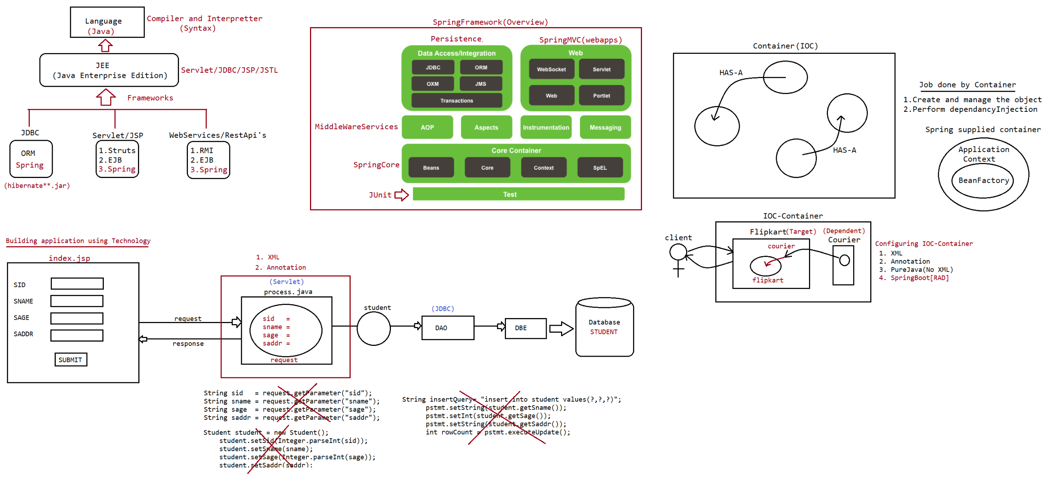
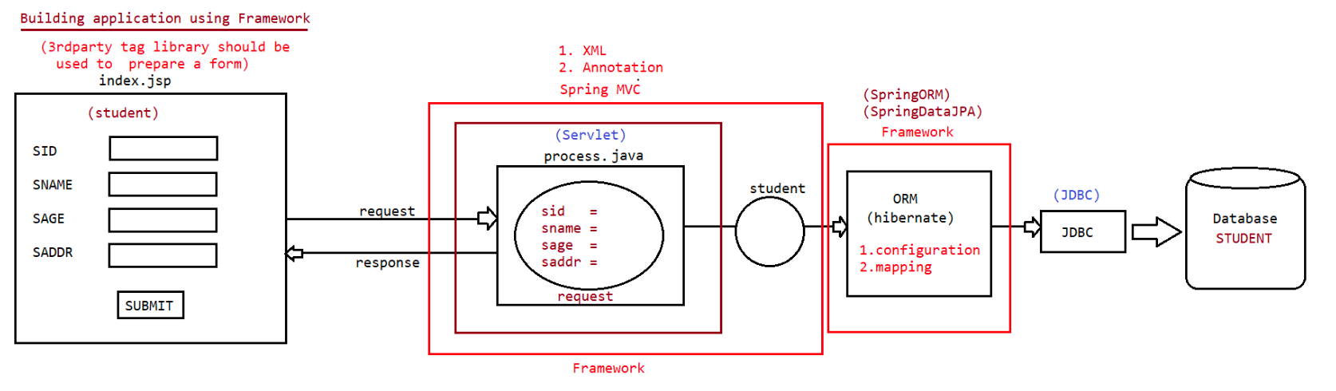
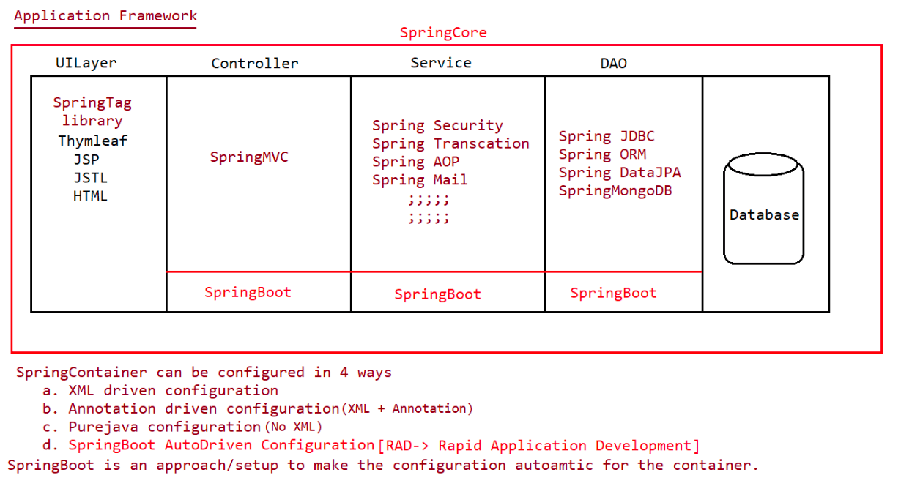
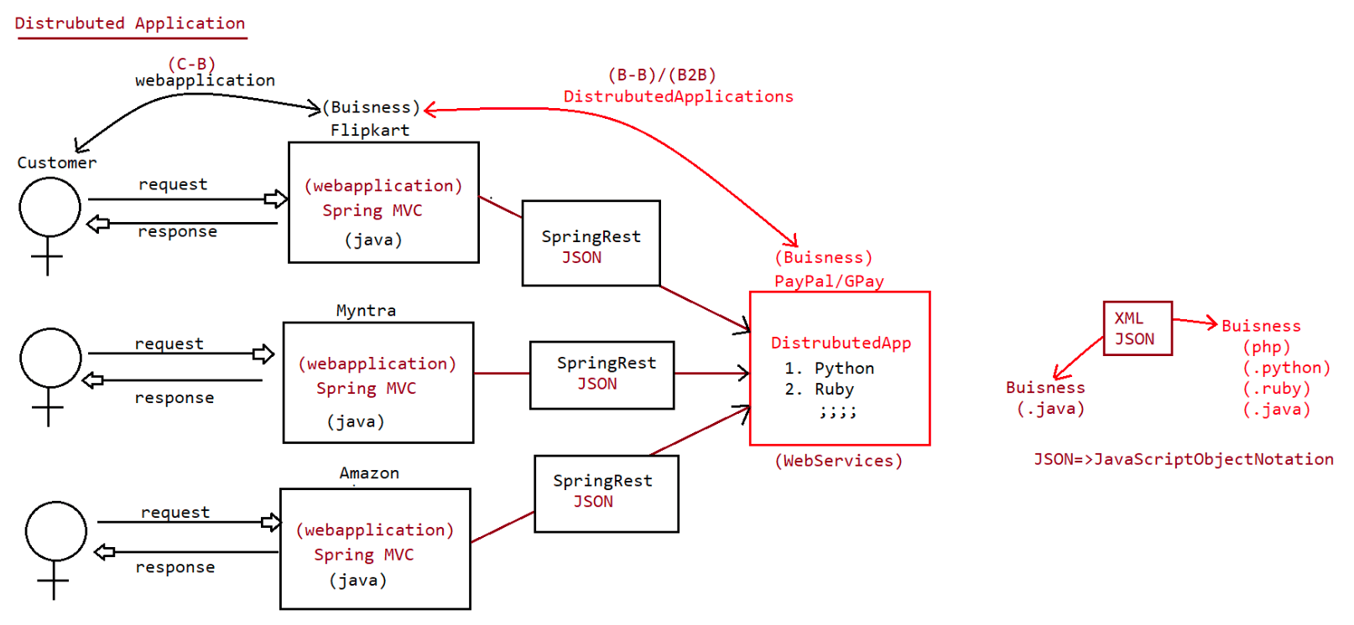
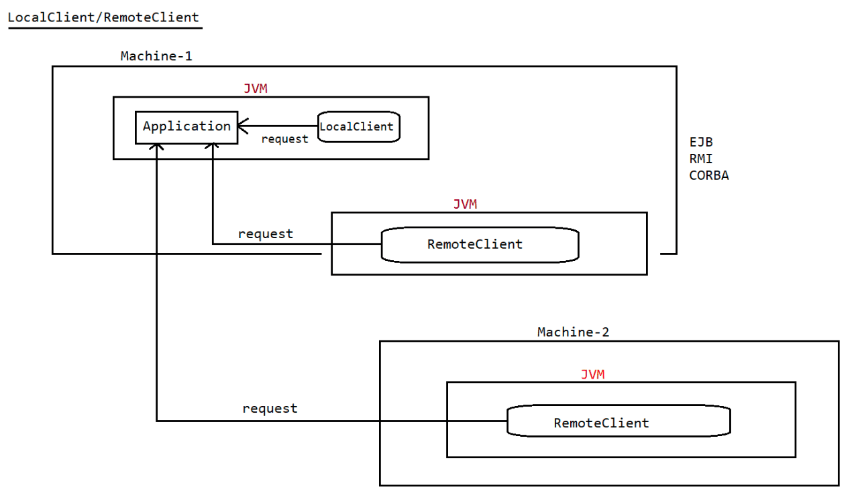

144 Setter and consturctor injection using BeanFactory(I) and ApplicationContext(I), Predicting the output for both Setter and ConstructorInjection

Spring jars can be downloaded from the following link
=> https://repo.spring.io/ui/native/release/org/springframework/spring/
Scroll down and search for link with Spring5.X version(5.3.17)
To add the namespace(xmlns),while writing the configuration file use the folowing
location
core.pdf
D:\jars\spring-5.3.17-dist\spring-framework-5.3.17\docs\reference\html\
Setter Injection
----------------
=> Here IOC container calls setter method of Target class to assign Dependant class
Object to target class Object.
=> java.util.Date(C)
|=> year(int),month(int),date(int)
|=> hours(int),minutes(int),seconds(int)
=> Setter injection will happen
a. Creating an object of Target component using zero param constructor.
b. Creating an object of Dependent component using Zero argument
constructor/parameterized constructor.
c. Calling setter method on Target component to perform dependency
injection.
=> BeanFactory container performs LazyLoading for all the beans present in spring
cfg file.
applicationContext.xml
---------------------
<beans xmlns="http://www.springframework.org/schema/beans"
xmlns:xsi="http://www.w3.org/2001/XMLSchema-instance"
xsi:schemaLocation="http://www.springframework.org/schema/beans
https://www.springframework.org/schema/beans/spring-beans.xsd">
<!-- Dependent spring bean cfg -->
<bean id="dt" class="java.util.Date"/>
<!-- Target spring bean cfg -->
<bean id="wmg" class="in.ineuron.comp.WishMessageGenerator">
<property name="date" ref="dt"/> ===> Instruction to IOCcontainer to Perform
Setter Injection.(wmg.setDate(dt))
</bean>
</beans>
Note:: In the <property> tag,"name" value is not a bean property name, it is the
word of setXXXX(,) method.
If the injection is of reference type, then we need to use <property
name="" ref=''/>.
If the inejction is of value type,then we need to use <property name=''
value=''/>
SetterInjection.java
--------------------
FileSystemResource resource = new
FileSystemResource("src/in/ineuron/cfg/applicationContext.xml");
System.out.println("***********BeanFactory container starting************");
XmlBeanFactory factory = new XmlBeanFactory(resource);System.out.println("***********BeanFactory container started*************");
WishMessageGenerator wmg = (WishMessageGenerator) factory.getBean("wmg",
WishMessageGenerator.class);
System.out.println(wmg);
String result = wmg.generateMessage("sachin");
System.out.println(result);
System.out.println();
System.out.println("*******Container is closing**********");
output
------
***********BeanFactory container starting************
***********BeanFactory container started*************
WishMessageGenerator.class file is loading...
WishMessageGenerator object is instantiated...
Setter method is called to perform Setter injection...
WishMessageGenerator [date=Tue Mar 21 20:35:30 IST 2023]
Good Night :: sachin
*******Container is closing**********
What is the difference b/w FileSystemResource and ClassPathResource?
=> Both are implementation classes of Resource(I)
=> FileSystemResource(C)
It makes the BeanFactory container to locate the given Springbean cfg file
from the Specified of path File System.
We can give either relative path(recomended) or absolute path of the spring
bean configuration file.
eg:: FileSystemResource res=new
FileSystemResource("src/in/ineuron/cfgs/applicationContext.xml");
=> ClassPathResource(C)
It makes the BeanFactory container to locate the given Springbean cfg file
from the directories or jar files that are added to
classpath or buildpath.
eg: ClassPathResource res=new
ClassPathResource("in/ineuron/cfgs/applicationContext.xml");
Constructor Injection
---------------------
Here IOC container uses parameterized constructor to create target class object.
In this process it assigns/injectes dependant object to the Target class Object.
In Setter injection first target class object is created,next Dependant object will
be created.
In case of Constructor injection,First Dependant class object should be
created,next target class object will be created and this dependant object will be
passed as the argument to the constructor.
syntax:
<bean id ='' class=''>
<constructor-arg name='' ref=''/>
</bean>
if we place<constructor-arg> tag for 'n' time under bean tag, then IOC container
uses "n-param" constructor to create the Spring bean class Object.Note: <ref> attribute to cfg bean id is based on Spring bean class object injection
to target bean class properites.
<value> to cfg is to inject "simple values" to Spring bean class properties.
In the <constructor-arg> tag, "name" value is not the bean property name, it
is the parameter name of the parameterized constructor.
Note:
What happens if we enable both setter injection and construcor injection to bean
property?
Tell me which id will be injected as final values?
Ans> Since setter method is called after the constructor execution, we say setter
injection overrides the value injected by the
constructor injection. Values/Object injected by the Setter injection will
become final values.
Note: In case of Setter injection, IOC container uses Zero parameter constructor to
create the Object.
In case of Constructor injection,IOC container use Parameterized constructor
to create the Object.
Note:
Bean id should be unique w.r.t IOC container
We can configure 2 spring beans having same class names but we should take
different bean id.
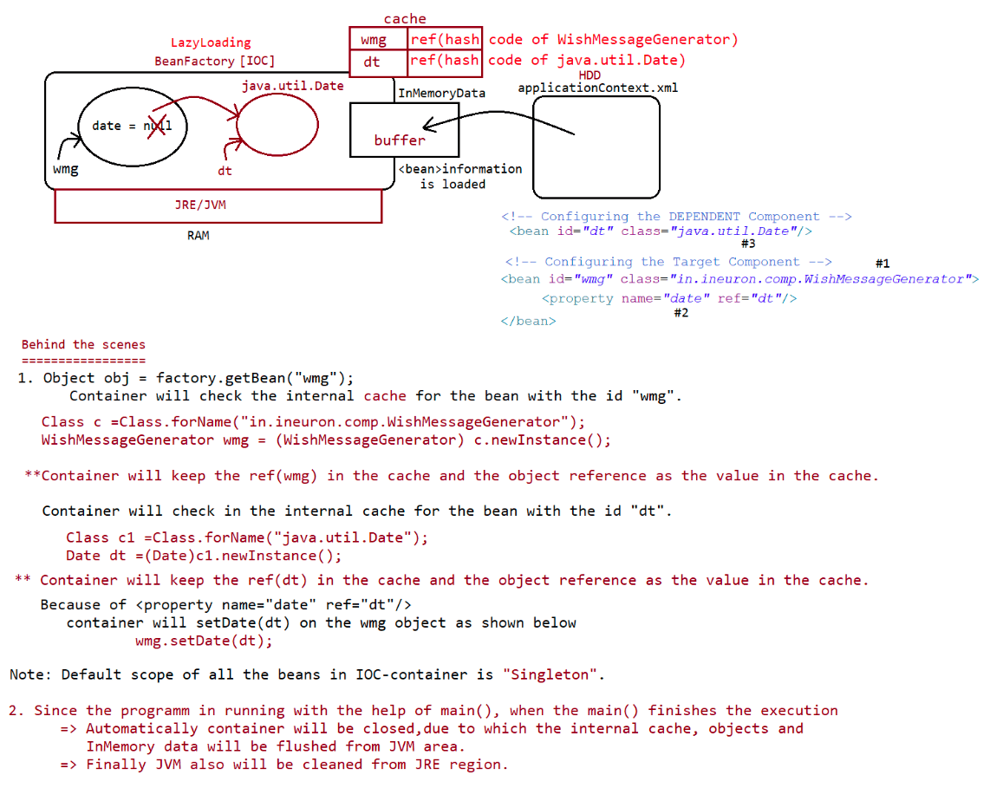
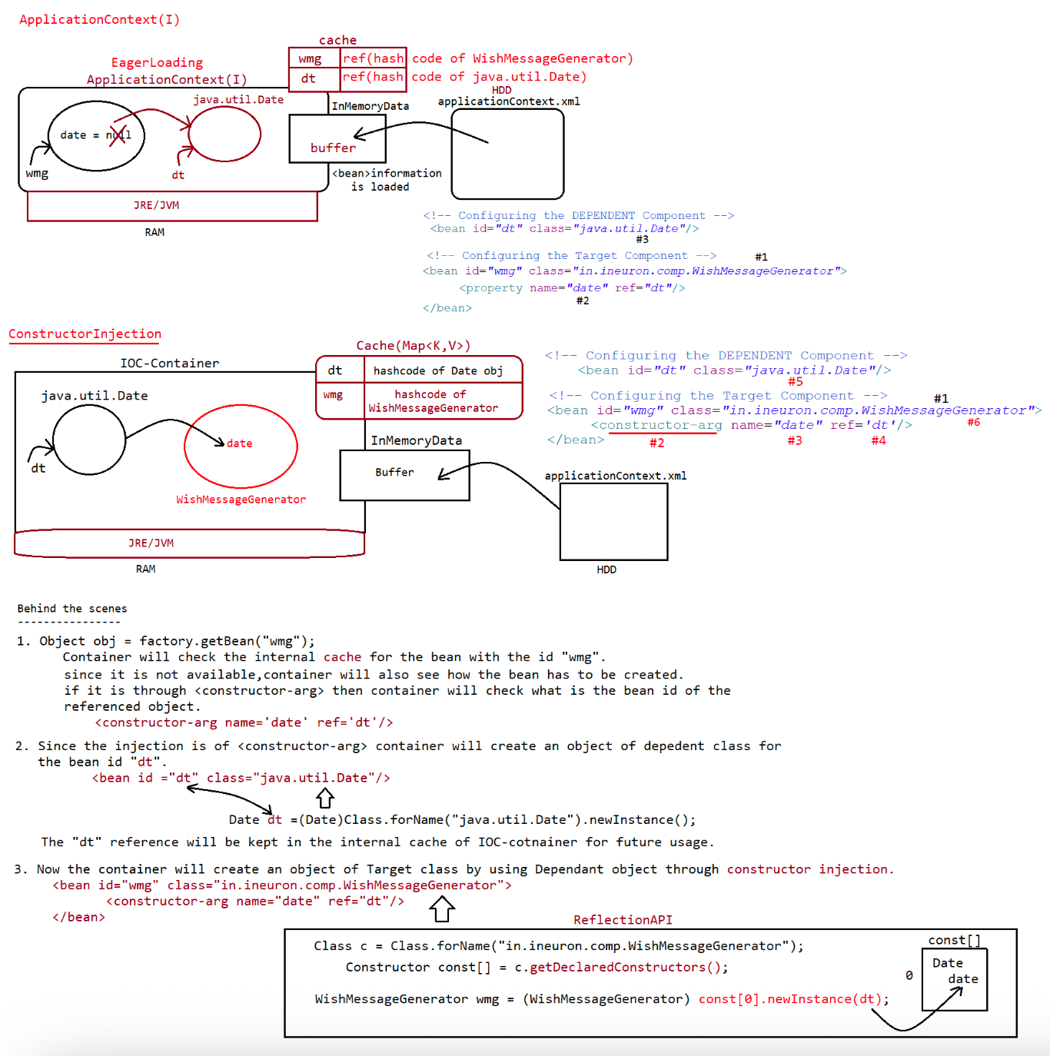

145 Spring consturctor injection using name,type,index attribute using XML,Cyclic dependancy using Setter,Constructor, One basic project to demonstrate DI, difference b w Setter and Constructor injection

Usage of index/type/name attribute in the <constructor-arg>
-----------------------------------------------------------
If there are mulitple params in constructor and if they have same datatype,then to
resolve the parameter binding from the container we need to go
either type/index/name(recomended)
private Integer eno;
private String ename;
private float esalary;
private String eaddress;
public Employee(Integer eno, String ename, float esalary, String eaddress) {
this.eno = eno;
this.ename = ename;
this.esalary = esalary;
this.eaddress = eaddress;
}
<constructor-arg value="MI" type='java.lang.String'/>
<constructor-arg value="sachin" type='java.lang.String'/>
<constructor-arg value="3500.05F" type='float'/>
<constructor-arg value="10" type='java.lang.Integer'/>
Injection from container
Employee [eno=10, ename=MI, esalary=3500.05, eaddress=sachin]
resolving the mismatch through index
------------------------------------
private Integer eno;
private String ename;
private float esalary;
private String eaddress;
public Employee(Integer eno, String ename, float esalary, String eaddress) {
this.eno = eno;
this.ename = ename;
this.esalary = esalary;
this.eaddress = eaddress;
}
<constructor-arg value="MI" index='3'/>
<constructor-arg value="sachin" index='1'/>
<constructor-arg value="3500.05F" index='2'/>
<constructor-arg value="10" index='0'/>
Employee [eno=10, ename=sachin, esalary=3500.05, eaddress=MI]
Resolving through name attribute
--------------------------------
private Integer eno;
private String ename;
private float esalary;
private String eaddress;
public Employee(Integer eno, String ename, float esalary, String eaddress) {
this.eno = eno;
this.ename = ename;
this.esalary = esalary;
this.eaddress = eaddress;
}
<constructor-arg value="MI" name='eaddress'/><constructor-arg value="sachin" name='ename'/>
<constructor-arg value="3500.05F" name='esalary'/>
<constructor-arg value="10" name='eno'/>
Employee [eno=10, ename=sachin, esalary=3500.05, eaddress=MI]
Note:What happens if we specify name,type,index attribute in one <constructor-arg>
tag at a time?
=> If all these are pointing to same param of consturctor.. then give value
will be injected to the param otherwise it would result in
"org.springframework.beans.factory.UnsatisfiedDependencyException".
Container work flow
-------------------
1. BeanFactory container ========> XmlBeanFactory(Depercated from Spring3.1V)
2. BeanFactory container ========> DefaultListableBeanFactory(C)
Limitations of XmlBeanFactory
=============================
1. Need of Resource object to hold the name and location of Spring bean
configuration file.
2. XmlBeanFactory uses XmlParser to read the bean defnition and to process the xml
file which is not good in terms of performance.
3. Doesn't allow to take multiple xml files at a time as spring bean configuration
file.
Advantages of DefaultListableBeanFactory
========================================
1. It directly recoginizes the beans,without passing this work to another class.
2. Allows to take multiple xml files at a time becoz loadDefnition(String... args)
argument is of var-args.
3. No need of taking Resource object to hold the name and location of spring bean
configuration file.
4. The performance towards reading and processing xml file is good.
One Project using SpringCore[DI technique to inject many dependant
objects[implementation classes of Courier] to Target class]
-----------------------------------------------------------------------------------
--------
1. Courier(I)
|=> DTDC,BlueDart,FirstFlight
2. Flipkart(C)
|=> Courier courier
Perform dependancy injection through setter approach and also demonstrate the usage
of "Scope of bean".
CircularDependancy Injection/Cyclic Dependancy Injection
=========================================================
=> It is all about making 2 classes dependent on each other.
=> It is not at all industry practise.
=> Setter injection supports CyclicDependancy/but Constructor injection doesn't
support CyclicDependancy.
=> One side Setter and another side Constructor injection would also support
"CyclicDependancy".Difference between Setter injection and Constructor injection
=============================================================
Setter Injection
=================
1. use setter method to inject the dependant values/objects to target class object.
2. <property name='' value=''/> and <property name='' ref=''/>
3. supports cylic dependancy injection
4. bit slow becoz injection happens after creating the Target class object.
5. First Target object and later Dependant object will be created.
6. It is best suited when we want to involve our choice no of properties in
dependancy injection.
7. If we configure spring bean in setter injection style,then container will create
the bean using "zero-arg" constructor.
Constructor Injection
=====================
1. use constructor to inject the dependant values/objects to target class object.
2. <constructor-arg name='' value=''/> and <constructor-arg name='' ref=''/>
3. Doesn't supports cylic dependancy injection
4. It is Fast becoz injection happens while instantiating the dependant class
object.
5. First Dependant object and later Target object will be created.
6. It is not best suited when we want to involve our choice no of properties in
dependancy injection,for this we need n! overloaded constructor.
7. If we configure spring bean in constructor injection style,then container will
create the bean using "n-param" constructor.
public class Student
{
private Integer sid;
private String sname;
private Integer sage;
private String cityName;
private String countryName;
private String stateName;
// 1 Zeroparam constructor
// 6 setXXXX methods
// toString()
}
<bean id="student" class ="in.ineuron.comp.Student">
<property name ="" value=""/>
<property name ="" value=""/>
<property name ="" value=""/>
</bean>
public class Student
{
private Integer sid;
private String sname;
private Integer sage;
private String cityName;
private String countryName;
private String stateName;
// n! -> no of consturctors with all combinations
// 1 6-param constructor// 2 3-param constructor
// 3 4-param constructor
// 6 setXXXX methods
// toString()
}
<bean id="student" class ="in.ineuron.comp.Student">
<constructor-arg name="cityName" value=""/>
<constructor-arg name="sname" value=""/>
<constructor-arg name="sid" value=""/>
<constructor-arg name="sage" value=""/>
</bean>
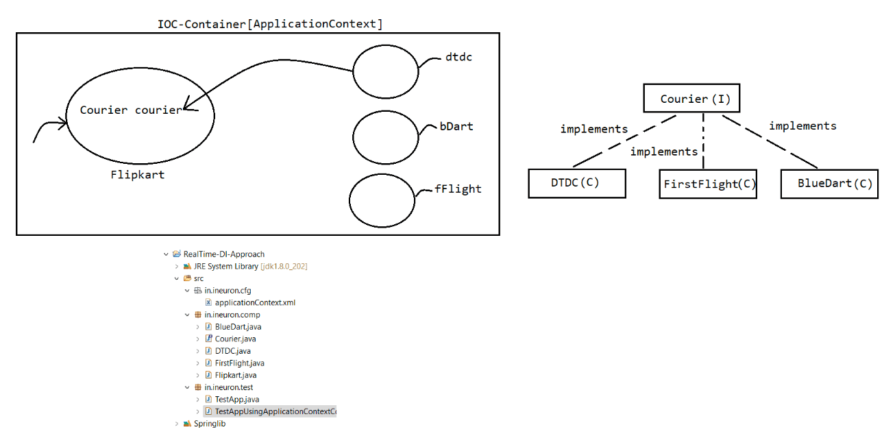
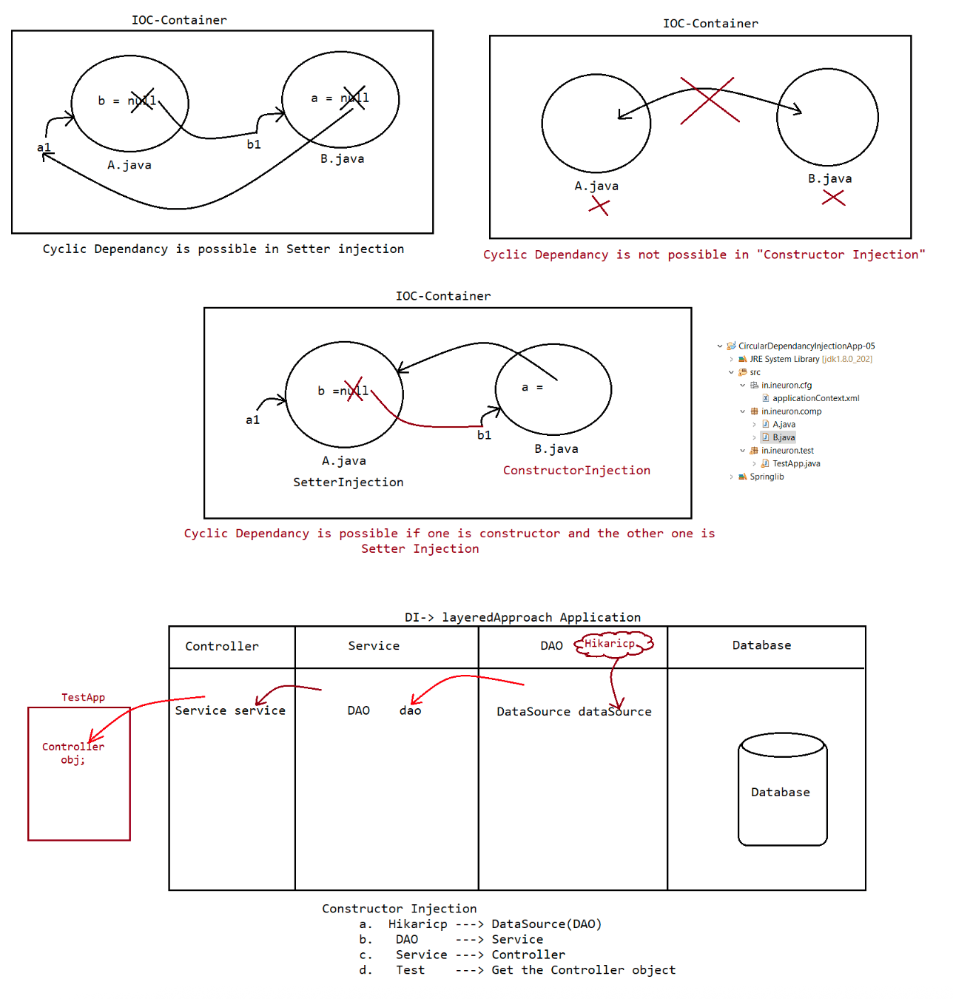

146 RealTimeDI using Xml file, RealTime DI using Xml and properties file,Scope in Spring Bean,default Bean id of Spring Bean

One Project using SpringCore[DI strategy by configuring the container]
----------------------------------------------------------------------
VO -> Value Object(it holds the data entered by the user, data would always be in
String format only)
BO -> Buisness Object(it holds the actual data which needs to persisted for future
usage)
DTO-> Data transfer Object(it holds the data in the required data type for
processing)
refer:: IOCProject-06-RealTimeDI-UsingXML
Reading the data from properites file into xml
----------------------------------------------
=> To read the data from properties file into xml by the container we need to use
"ApplicationContext(I)" IOC container.
applicationContext.xml
---------------------
<beans xmlns="http://www.springframework.org/schema/beans"
xmlns:xsi="http://www.w3.org/2001/XMLSchema-instance"
xmlns:context="http://www.springframework.org/schema/context"
xsi:schemaLocation="http://www.springframework.org/schema/beans
https://www.springframework.org/schema/beans/spring-beans.xsd
http://www.springframework.org/schema/context
https://www.springframework.org/schema/context/spring-context.xsd">
<!-- Setter Injection to get DataSource Object -->
<bean id ="mysqlDAO"
class="org.springframework.jdbc.datasource.DriverManagerDataSource">
<property name="driverClassName" value="${jdbc.driverClassName}"/>
<property name="url" value="${jdbc.url}"/>
<property name="username" value="${jdbc.username}"/>
<property name="password" value="${jdbc.password}"/>
</bean>
<context:property-placeholder
location="in/ineuron/commons/application.properties"/>
</beans>
application.properites
----------------------
jdbc.url=jdbc:mysql:///octbatch
jdbc.driverClassName=com.mysql.cj.jdbc.Driver
jdbc.username=root
jdbc.password=root123
TestApp.java
------------
ClassPathXmlApplicationContext factory = new
ClassPathXmlApplicationContext("in/ineuron/cfg/applicationContext.xml");
Output
------
CustomerMySQLDAOImpl:: 1 param constructor ----->
org.springframework.jdbc.datasource.DriverManagerDataSourceCustomerMgmtServiceImpl:: 1 param constructor---->
in.ineuron.dao.CustomerMySQLDAOImpl
MainController:: 1 param constructor-----
>in.ineuron.service.CustomerMgmtServiceImpl
Scope attribute in Spring
-------------------------
singleton(default)
=> It is the default scope for a particular bean in spring.
=> IOC container will never make spring bean class as singleton java class,
but it creates only
one object, keeps that object in internal cache and returns that object
every time we make a call to
factory.getBean().
application.xml
--------------
<bean id="wmg" class="in.ineuron.bean.WishMessgeGenerator" scope="singleton">
<property name="date" ref='dt'/>
</bean>
ClientApp.java
--------------
WishMessageGenerator generator1= factory.getBean("wmg", WishMessgeGenerator.class);
WishMessageGenerator generator2= factory.getBean("wmg", WishMessgeGenerator.class);
System.out.println("Generator1 class object reference :: "+generator1.hashCode());
System.out.println("Generator2 class object reference :: "+generator2.hashCode());
output
Generator1 class object reference :: 1442045361
Generator2 class object reference :: 1442045361
prototype
=>IOC container creates a new object for Spring bean class for every
factory.getBean() method.
=>IOC container doesn't keep this scope spring bean class objects in
"internal cache" of IOC container.
application.xml
--------------
<bean id="wmg" class="in.ineuron.bean.WishMessgeGenerator" scope="prototype">
<property name="date" ref='dt'/>
</bean>
ClientApp.java
--------------
WishMessageGenerator generator1= factory.getBean("wmg", WishMessgeGenerator.class);
WishMessageGenerator generator2= factory.getBean("wmg", WishMessgeGenerator.class);
System.out.println("Generator1 class object reference :: "+generator1.hashCode());
System.out.println("Generator2 class object reference :: "+generator2.hashCode());
output
Generator1 class object reference :: 214074868
Generator2 class object reference :: 1442045361
will be discussed in webapplication(httpprotocol)
=================================================
request
sessionapplication
websocket
Note: If we use ApplicationContext(I) container, then the beans will created in
eager loading style only for such beans whose scope is
"singleton", if it is "prototype" scope then it would perform lazy loading.
If we use BeanFactory(I) container, then beans will be created in lazy
loading style irrespective of bean scopes.
Note: Can we make SpringIOC container to create only one object, even if the scope
is prototype?
ans. Yes, by writing our own design pattern code and also using an
attribute called <bean ... factory-method=""> in xml file.
Printer.java
============
public class Printer {
private static Printer INSTANCE = null;
private Printer() {
// TODO Auto-generated constructor stub
}
static {
System.out.println("Printer.class file is loading...");
}
public static Printer getInstance() {
System.out.println("Printer.getInstance()");
if (INSTANCE == null) {
INSTANCE = new Printer();
}
return INSTANCE;
}
@Override
public String toString() {
return "Printer [hashCode()=" + hashCode() + "]";
}
}
applicationContext.xml
======================
<bean id="printer" class="in.ineuron.comp.Printer" scope="prototype" factory-
method="getInstance"/>
TestApp.java
------------
ClassPathXmlApplicationContext factory = new
ClassPathXmlApplicationContext("in/ineuron/cfg/applicationContext.xml");
System.out.println("*********Container started**********");
System.in.read();
Printer p1 = factory.getBean("printer", Printer.class);
System.out.println(p1);
Printer p2 = factory.getBean("printer", Printer.class);
System.out.println(p2);factory.close();
System.out.println("\n*********Container stopped**********");
Output
======
Printer.class file is loading...
Printer.getInstance()
Printer [hashCode()=222624801]
Printer.getInstance()
Printer [hashCode()=222624801]
Default bean id
===============
If we don't specify <bean id=""> in applicationContex.xml file then after creating
the object the container will give the default bean as
show below.
id = "fullyqualifiedclassname#0".
applicationContext.xml
----------------------
<bean class="in.ineuron.comp.Student">
<property name="sid" value="10"/>
<property name="sname" value="sachin"/>
<property name="sage" value="49"/>
<property name="saddress" value="MI"/>
</bean>
<bean class="in.ineuron.comp.Student">
<property name="sid" value="7"/>
<property name="sname" value="dhoni"/>
<property name="sage" value="41"/>
<property name="saddress" value="CSK"/>
</bean>
Student.java
===========
public class Student{
private Integer sid;
private String sname;
private Integer sage;
private String saddress;
setXXX(),Zeroparam constructor,toString()
}
TestApp.java
=============
ClassPathXmlApplicationContext factory = new
ClassPathXmlApplicationContext("in/ineuron/cfg/applicationContext.xml");
System.out.println("*********Container started**********");
System.out.println("Bean id is :: " +
Arrays.toString(factory.getBeanDefinitionNames()));
System.in.read();
Student stud1 = factory.getBean("in.ineuron.comp.Student#0", Student.class);
System.out.println(stud1);Student stud2 = factory.getBean("in.ineuron.comp.Student#1", Student.class);
System.out.println(stud2);
factory.close();
System.out.println("\n*********Container stopped**********");
Output
=====
Student.class file is loading...
Student object :: Zero param constructor
Student object :: Zero param constructor
*********Container started**********
Bean id is :: [in.ineuron.comp.Student#0, in.ineuron.comp.Student#1]
Student [sid=10, sname=sachin, sage=49, saddress=MI]
Student [sid=7, sname=dhoni, sage=41, saddress=CSK]
*********Container stopped**********

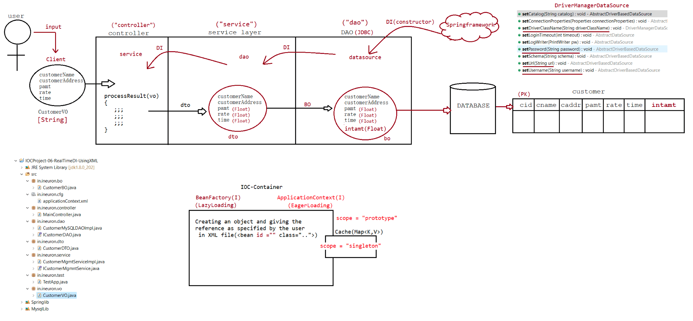

147 Collection Injection,usage of Collection Injection in real time code,usage of <import resource="" > ,null injection,bean inheritance, usage of bean inheritance in real time development.

Note:
While developing layered application,Instead of configuring all DAO
classes,ServiceClass,Controller Class
as a springbean in single configuration file(.cfg.xml),It is recomended to take
multiple xml files and link
them to single xml file.
<beans ......>
<import resource="location of .xml file"/>
</beans>
applicationContext.xml
======================
<?xml version="1.0" encoding="UTF-8"?>
<beans xmlns="http://www.springframework.org/schema/beans"
xmlns:xsi="http://www.w3.org/2001/XMLSchema-instance"
xmlns:context="http://www.springframework.org/schema/context"
xsi:schemaLocation="http://www.springframework.org/schema/beans
https://www.springframework.org/schema/beans/spring-beans.xsd
http://www.springframework.org/schema/context
https://www.springframework.org/schema/context/spring-context.xsd">
<import resource="controller-beans.xml" />
<import resource="service-beans.xml" />
<import resource="persistence-beans.xml" />
</beans>
Collection Injection
--------------------
=> It is all about injecting values to array,collection type bean properties
through Dependancy injection.
Property type tag/attribute
=================================================
simple/primitive ====> <value>
object ====> <ref>
array ====> <array>/<list>
List ====> <list>
Set ====> <set>
Map ====> <map>
Properties ====> <props>
applicationContext.xml
======================
<?xml version="1.0" encoding="UTF-8"?>
<beans xmlns="http://www.springframework.org/schema/beans"
xmlns:xsi="http://www.w3.org/2001/XMLSchema-instance"
xsi:schemaLocation="http://www.springframework.org/schema/beans
https://www.springframework.org/schema/beans/spring-beans.xsd">
<bean id="sysDate" class="java.util.Date" />
<bean id="dob" class="java.util.Date">
<property name="year" value="93" />
<property name="month" value="0" />
<property name="date" value="03" />
</bean><!--Array Injection-->
<bean id="marks" class="in.ineuron.comp.MarksInfo">
<property name="marksInfo">
<array>
<value>100</value>
<value>97</value>
<value>98</value>
<value>35</value>
</array>
</property>
</bean>
<!--List Injection-->
<bean id="clg" class="in.ineuron.comp.College">
<property name="studNames">
<list>
<value>sachin</value>
<value>saurav</value>
<value>dravid</value>
<value>laxman</value>
</list>
</property>
<property name="dateList">
<list>
<ref bean="sysDate" />
<ref bean="dob" />
</list>
</property>
</bean>
<!--Set Injection-->
<bean id="contact" class="in.ineuron.comp.ContactsInfo">
<property name="phoneNumbers">
<set value-type="java.lang.Long">
<value>9999999999</value>
<value>8888888888</value>
<value>7777777777</value>
<value>7777777777</value>
</set>
</property>
<property name="dates">
<set>
<ref bean="sysDate" />
<ref bean="dob" />
</set>
</property>
</bean>
<!--Map Injection-->
<bean id="uInfo" class="in.ineuron.comp.UniversityInfo">
<property name="facultyDetails">
<map key-type="java.lang.Integer" value-type="java.lang.String">
<entry>
<key>
<value>10</value>
</key>
<value>sachin</value>
</entry><entry key="7" value="dhoni" />
<entry key="18" value="kohli" />
</map>
</property>
<property name="datesInfo">
<map key-type="java.lang.String" value-type="java.util.Date">
<entry>
<key>
<value>toDay</value>
</key>
<ref bean="sysDate" />
</entry>
<entry key="dob" value-ref="dob"/>
</map>
</property>
<!-- Property Injection -->
<property name="iplInfo">
<props>
<prop key="RCB">FAF</prop>
<prop key="MI">Rohith</prop>
<prop key="CSK">Dhoni</prop>
<prop key="LSG">Rahul</prop>
<prop key="GT">Pandya</prop>
<prop key="KKR">Iyer</prop>
</props>
</property>
</bean>
</beans>
Collection injection in realtime
================================
DriverManagerDataSource(C)
|-> driverClassName
|-> url
|-> connectionProperties(java.util.Properties object with fixed key called
"user" and "password")
|-> user
|-> password
applicationContext.xml
======================
<beans xmlns="http://www.springframework.org/schema/beans"
xmlns:xsi="http://www.w3.org/2001/XMLSchema-instance"
xmlns:context="http://www.springframework.org/schema/context"
xsi:schemaLocation="http://www.springframework.org/schema/beans
https://www.springframework.org/schema/beans/spring-beans.xsd
http://www.springframework.org/schema/context
https://www.springframework.org/schema/context/spring-context.xsd">
<!-- Setter Injection to get DataSource Object -->
<bean id="mysqlDAO"
class="org.springframework.jdbc.datasource.DriverManagerDataSource"
scope="singleton">
<property name="driverClassName" value="${jdbc.driverClassName}" />
<property name="url" value="${jdbc.url}" />
<!--Properties injection to inject user-name and password of database
--><property name="connectionProperties">
<props>
<prop key="user">${jdbc.user}</prop>
<prop key="password">${jdbc.password}</prop>
</props>
</property>
</bean>
<context:property-placeholder
location="in/ineuron/commons/application.properties" />
</beans>
NullInjection
------------
In constructor injection, all params must participate in injection process
otherwise it would result in "Exception".
If constructor param type is object/reference type and we are not ready with value
then we can go for null injection.
This is very handy(useful) when we are working with predeifned classes as a spring
bean, that is a spring bean will have limited no of
Overloaded constructors and no setter injection support is available.
syntax: <constructor-arg name=''><null/></constructor-arg>
applicationContext.xml
======================
<?xml version="1.0" encoding="UTF-8"?>
<beans xmlns="http://www.springframework.org/schema/beans"
xmlns:xsi="http://www.w3.org/2001/XMLSchema-instance"
xsi:schemaLocation="http://www.springframework.org/schema/beans
https://www.springframework.org/schema/beans/spring-beans.xsd">
<bean id="pinfo" class="in.ineuron.comp.PersonInfo">
<constructor-arg name="pid" value="10"/>
<constructor-arg name="pname" value="sachin"/>
<constructor-arg name="paddress" value="MI"/>
<constructor-arg name="dom"><null/></constructor-arg>
<constructor-arg name="doj"><null/></constructor-arg>
<constructor-arg name="dob" ref="dobObj"/>
</bean>
<bean id="dobObj" class="java.util.Date">
<property name="year" value="93"/>
<property name="month" value="0"/>
<property name="date" value="03"/>
</bean>
</beans>
Person.java
===========
public class PersonInfo {
private Integer pid;
private String pname;
private String paddress;
private Date dob;
private Date dom;
private Date doj;
public PersonInfo(Integer pid, String pname, String paddress, Date dob, Datedom, Date doj) {
System.out.println("PersonInfo:: 6 param constructor...");
this.pid = pid;
this.pname = pname;
this.paddress = paddress;
this.dob = dob;
this.dom = dom;
this.doj = doj;
}
toString()
}
output
======
PersonInfo [pid=10, pname=sachin, paddress=MI, dob=Sun Jan 03 21:47:30 IST 1993,
dom=null, doj=null]
Can we do null injection while working with setter injection?
Ans. yes, but not required becoz while working with setter injection there is
no mandatory to inject value/object to bean property.
we can involve our choice properties in setter injection,more over the
reference type/object type bean properties by default holds
null values.
<property name="dob"><null/></property>
Bean inheritance
---------------------
<bean id='baseCar' class="in.ineuron.bean.Car" abstract="true">
<constructor-arg name="engineCC" value='1500' />
<constructor-arg name="model" value='swift' />
<constructor-arg name="company" value='suziki' />
<constructor-arg name="fuelType" value='diesel' />
<constructor-arg name="type" value='hatchback' />
</bean>
<bean id='car1' class='in.ineuron.bean.Car' parent="baseCar">
<constructor-arg name="owner" value='sachin' />
<constructor-arg name="regNo" value='KA4567' />
<constructor-arg name="color" value='red' />
<constructor-arg name="engineNo" value='12345' />
</bean>
<bean id='car2' class='in.ineuron.bean.Car' parent="baseCar">
<constructor-arg name="owner" value='dhoni' />
<constructor-arg name="regNo" value='JH5647' />
<constructor-arg name="color" value='white' />
<constructor-arg name="engineNo" value='56789' />
</bean>
Car car3 = factory.getBean("baseCar", Car.class);
System.out.println(car3);
Output
org.springframework.beans.factory.BeanIsAbstractException(class is abstract
so)
Important points of inheritance in bean configuration file----------------------------------------------------------
1. This is not a class level inheritance, it is spring bean cfg file level bean
properties inheritance across multiple spring bean cfgs.
2. <bean abstrat='true'> will neve make the class as abstract,but it makes spring
bean cfg as abstract.
3. One spring bean can inherit and resuse the spring bean properties only from one
spring bean..
Bean inheritance in realtime
---------------------------
DataSource(I)===> javax.sql.*
|
DriverManagerDataSource(C)===> org.spring.**
|
HikariDatasource(C) ======> com.zaxxer.**
persistence.xml
----------------------
<bean id="mysqlDataSource"
class="org.springframework.jdbc.datasource.DriverManagerDataSource">
<property name="driverClassName" value='com.mysql.cj.jdbc.Driver' />
<property name="username" value='root' />
<property name="password" value='root123' />
</bean>
<bean id='hikariDataSource' class='com.zaxxer.hikari.HikariDataSource'
parent="mysqlDataSource">
<property name="jdbcUrl" value='jdbc:mysql:///enterprisejavabatch' />
<property name="minimumIdle" value='10' /><!-- min pool size -->
<property name="maximumPoolSize" value='20' />
<property name="connectionTimeout" value='2000' />
</bean>
<!-- DAO Configuration -->
<bean id='mysqlDaoImpl' class='in.ineuron.dao.CustomerMySQLDAOImp'>
<constructor-arg name='dataSource' ref='hikariDataSource' />
</bean>
Design a layered approach application to perform CRUD opearation on database called
Employee using SpringCore
Concepts to be used are
a. Properties file injection
b. use BeanInheritane and work with hikaricp
c. use Collection injection
d. use VO,BO,DTO approach
a. Employee => eid,ename,eage,eaddress
operation performed are
a. insert
b. update(by doing validation)
c. delete
d. read based on id
e. getAllRecords

